Business Requirements Document (BRD)

# Timesheet Management System

Prepared by: SANDILE TSHABALALA

Date: June 25, 2025

Due Date: 27 June 2025

## 1. System Overview

### Purpose

The Timesheet System is designed to enable employees to accurately log work hours, allocate time to tasks or projects, and submit these records for managerial approval. It aims to streamline time tracking, improve payroll accuracy, and ensure labor compliance.

### Key Stakeholders

- Employees: Submit and manage their timesheets.  
- Managers: Review, approve, or reject timesheets.  
- HR Department: Monitor attendance, overtime, and leave.  
- Payroll Team: Use timesheet data for salary processing.  
- System Administrators: Manage system configuration and users.

### High-Level Goals and Outcomes

• Provide an intuitive platform for logging and tracking work hours.  
• Automate approval workflows and notifications.  
• Ensure secure, compliant storage of time records.  
• Support data analysis through reports and dashboards.

## 2. User Roles and Permissions

|  |  |
| --- | --- |
| User Type | Permissions |
| Employee | Submit/edit/view own timesheets, view approval status, receive notifications. |
| Manager | View/edit/approve/reject timesheets of team members, access team reports. |
| HR Admin | View all timesheets, run reports, access leave info, manage holiday calendar. |
| System Admin | Full system access: manage users, settings, integrations, logs, and audit trail. |

## 2.1 Use Case Scenarios – Diagram

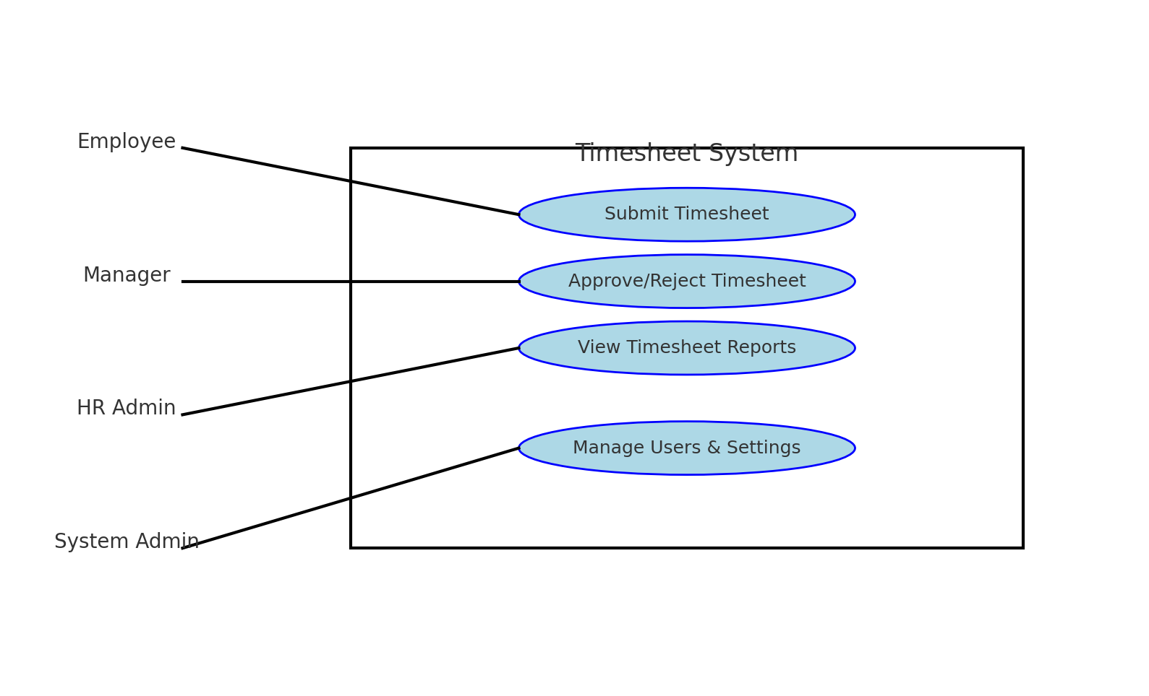

## 3. Functional Requirements

### Timesheet Entry

Daily/Weekly/Monthly Logging; Project/Task Tracking; Breaks/Leave/Overtime

### Timesheet Approval

Workflow; Notifications

### Editing and Resubmission

Edit rejected or approved timesheets

### Leave Integration (Future Enhancement)

Sync with leave management system; auto-adjust holidays

### Reporting and Analytics

Individual/Team reports; PDF/Excel export; Dashboard summaries

## 4. Non-Functional Requirements

### Performance

Page load < 2s; 500+ users

### Availability

99.9% uptime

### Security

Encryption; access control

### Compliance

Labour laws; company policies

## 5. Integration Requirements (Future Enhancement)

### Integrations

Payroll, HR, Leave systems

## 6. UI/UX Requirements

### Design

User-friendly; responsive; mobile-compatible

### Error Handling

Clear messages; validation

## 7. Notification System

### Channels

Email and in-app

### Events

Submission, approval, rejection, reminders

### Reminders

Configurable

## Approval Section

|  |  |  |  |
| --- | --- | --- | --- |
| Name | Role | Signature | Date |
| Manager | Team Lead |  |  |
| HR Representative | HR Manager |  |  |
| IT Manager | Systems Admin |  |  |

## 8. Technical Architecture

### Frontend

* Framework: ReactJS
* Libraries: Axios (API calls), React Hook Form (form handling), Tailwind/Bootstrap (optional styling)
* Features: Responsive timesheet UI, dashboard charts, approval modals

### Backend

* Language: C#
* Framework: ASP.NET Core Web API
* Authentication: ASP.NET Identity with JWT for secure API access
* Database: SQL Server (or PostgreSQL)
* Services: TimesheetService, ApprovalService, NotificationService, ReportService

### API Endpoints (examples)

* POST /api/timesheets – Submit new timesheet
* GET /api/timesheets/{employeeId} – Fetch employee timesheets
* PUT /api/timesheets/{id}/approve – Approve timesheet
* GET /api/reports/team – Team timesheet reports

### Notifications

* Implementation: SignalR (real-time in-app updates), SMTP (email)
* Events: Submission, approval, rejection, overdue

## 10. Audit Trail and Logs

### Tracking

Logs for submit/edit/approve with timestamps and users

### Access

HR and System Admin only

## 9. DevOps & CI/CD

* Version Control: GitHub/GitLab
* CI/CD: GitHub Actions or Azure DevOps
* Deployment: Azure App Services or IIS for ASP.NET Core backend
* Monitoring: Application Insights / Log Analytics

## 11. Testing & Validation Requirements

### Types

Unit, System, Integration, UAT

## 12. Deployment and Support

### Rollout Plan

Pilot testing; full rollout

### Training

Sessions; manuals; FAQs

### Support

Bug tracking; SLA: Critical – 24h